Multiple Choice: (1 mark each)

1. What is the main criterion for designating the corresponding layers of the atmosphere?
(A) The composition of each layer
(B) The temperature in each layer
(C) The density of each layer
(D) The type of reaction occurring in each layer
Ans.: B Outcome:H13
2. The formation of ozone in the troposphere is due to which situation?

(A) presence of the very short UV radiation acting on an oxygen molecule
(B) presence of medium short frequency UV radiation acting on nitric oxide molecules
(C) presence of low frequency UV radiation acting on nitrogen dioxide molecules
(D) presence of medium high frequency UV acting on hydrocarbons

Ans:B Outcomes:H8

3. What is the correct IUPAC name of a compound whose condensed structural formula is CF₃CHClCH₃?

(A) 2-chloro-1,1,1-trifluoropropane
(B) 2-chloro-3,3,3-trifluoropropane
(C) 1,1,1-trifluro-2- chloropropane
(D) 3,3,3-trifluro-2-chloropropane

Ans A: Outcomes H13

4. Which chemical reaction given below supports the information given in the following diagram?
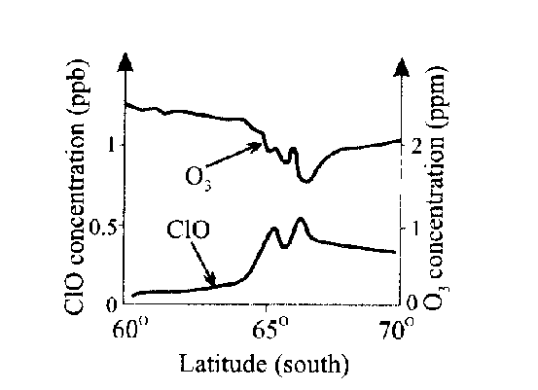

(A) 2 ClO (g) → Cl₂O₂(g)
(B) Cl₂O₂ (g) → 2 Cl (g) + O₂(g)
(C) ClO(g) + O₂(g) → Cl(g) + O₃(g)
(D) Cl(g) + O₃(g) → ClO(g) + O₂ (g)

Ans:D Outcomes H6, H7, H9

5. Which of the following choices correctly describes the thermosphere, troposphere and stratosphere?

 | THERMOSPHERE | TROPOSPHERE | STRATOSPHERE
(A) | Ozone destroyed in this layer  due to high temperature | Lowest layer of the atmosphere | Ozone produced in this layer
(B) | Hottest layer | Layer surrounding the Earth’s surface | Layer with the most pollutants
(C) | CFCs destroyed in this layer | Ozone formed in this layer due to  high UV flux | Highest layer
(D) | Highest layer | Layer with the most pollutants | Ozone formed and destroyed  in this layer

Answer (D)
Outcome H4

6. Water authorities regularly test drinking water to ensure the health of the populace.
Which of the test profiles would be indicative of high quality water?

 | TDS | DO | BOD
(A) | high | high | high
(B) | high | low | high
(C) | low | high | low
(D) | low | low | low

Answer (C)
Outcome H4

7. The table lists ions to be identified and test solutions.

ION TO BE IDENTIFIED | TEST SOLUTION USED
① Ba ²⁺ | ⑤ AgNO₃
② Cl – | ⑥ BaCl₂
③ CO₃ ^{2–} | ⑦ HNO₃
④ SO₄ ^{2–} | ⑧ H₂SO₄

Which of the following sets shows the correct matching?

(A) 1 + 8; 2 + 5; 3 + 7; 4 + 6
(B) 1 + 5; 2 + 8; 3 + 6; 4 + 7
(C) 1 + 7; 2 + 6; 3 + 5; 4 + 8
(D) 1 + 6; 2 + 7; 3 + 8; 4 + 5

Answer (B)
Outcome H6

Study these Lewis electron dot structures…
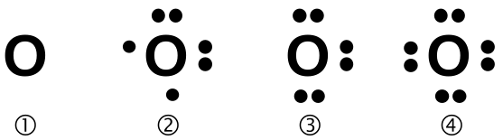


Which pair represents the correct structures of oxygen (free radical) and ozone?

(A) 1 and 6
(B) 2 and 7
(C) 3 and 8
(D) 4 and 5

Answer (B)
Outcome H6

Answer Booklet for Sections A and B Student No....................................

INSTRUCTIONS
Use the multiple choice answer sheet below.
Select the alternative A, B, C or D that best answers the question. Fill in the response square completely.

Sample 2+4= (A) 2 (B) 6 (C) 8 (D)9

A ① B  C ① D ①

If you think you have made a mistake, put a cross through the incorrect answer and fill in the new answer.

A  B  C ① D ①

If you change your mind and have crossed out what you consider to be the correct answer, then indicate this by writing the word correct and drawing an arrow as follows:

correct

A  B  C ① D ①

Section A

Multiple Choice Answer Sheet

1. A ① B  C ① D ①

2. A ① B  C ① D ①

3. A  B ① C ① D ①

4. A ① B ① C ① D 

5. A ① B ① C ① D 

6. A ① B ① C  D ①

7. A ① B  C ① D ①

8. A ① B  C ① D ①

MARKS

Section B:
Short Answer Questions

Question 9
Your recent labwork involved the identification of the following ions…

phosphate, sulfate, carbonate, chloride, barium, calcium, lead,
copper and iron

(a) Identify one of these ions and explain why its presence must be
monitored in substances used by society. 2

Outcome: H4

Answer: Lead is monitored in water supplies and food because it is toxic.

– OR –

Phosphate is monitored in water supplies because it can cause blue-green algal blooms which are toxic.

(b) Describe the chemical test and a positive result for the presence of the
aqueous ion identified in (a) 1

Outcome: H8

Answer: Lead ion is tested by reaction with dilute HCl resulting in a white ppt. which is soluble in hot water.
Alternatively, test with KI resulting in a distinctive golden yellow precipitate.

– OR –

Phosphate ion is tested by reaction with ammonium molybdate solution.
When warmed a yellow precipitate results.
Alternatively, add a solution of NH₃ and Ba(NO₃)₂ resulting in a white ppt.
Then add, ammoniated Mg²⁺ + NH₄NO₃ buffer producing a final white ppt.

MARKS

Question 10

The following reactions can occur in the atmosphere…

• H₂O (l) 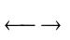 H₂O (g)
• CF₂Cl₂ 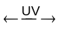 CF₂Cl + Cl
• O₂ + O 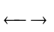 O₃
• SO₂ + H₂O 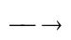 H₂SO₃

Draw the Lewis electron dot structure of a free radical species found above. 1

Outcome: H6

Answer:  or 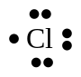 or CF₂Cl •

Question 11
Describe the conditions under which rusting of iron occurs. Use half equations
to justify your answers 2

For rusting of iron to occur, both oxygen and water are required to be present.
Outcome:H13

Anode reaction: Fe → Fe²⁺ + 2e⁻
Cathode reaction: O₂ + 2 H₂O + 4e⁻ → 4 OH⁻

Question 12

Describe the work of Davy and Faraday in increasing understanding of
electron transfer reactions. 2

. Outcome:H1, H2, H3

Davy used Volta's pile to electrolyse water and produce metals such as potassium, and sodium. Davy correctly recognised that it was the chemical reaction was the source of the electric current. Although, both Davy and Faraday made use of electric current to decompose substances,. it was Faraday, who continued on to quantitative electrolysis with his coulometer.

MARKS
Question 13

Identify alternative chemicals used to replace CFCs and evaluate the
effectiveness of their use as a replacement for CFCs. 3

Outcomes:H4, H16
Alternative chemicals are the HCFCs, hydrochlorofluorocarbons and the
HFCs, hydrofluorocarbons. The HCFCs are only half effective as a
replacement for CFCs because although they are mostly degraded in the
troposphere, a small amount still reach the stratosphere to destroy ozone.
The HCFs are more effective as a CFC replacement than the HCFCs.
They are degraded in the troposphere but because they contain no C-Cl
bonds, do not destroy ozone. They are however, less efficient and more
expensive than the CFCs.

Question 14 (3 marks)

Describe the design and composition of microscopic membrane filters and explain how they purify contaminated water.

A membrane filter is a thin film of a synthetic polymer ( such as polypropylene, polytetrafluroethylene and polysulfone). through which there are pores (small holes) of fairly uniform size. Water is passed through the membrane and particles bigger than these pore sizes are filtered off. The simplest type is just a sheet of porous polymer that is pleated a around a central rigid porous core and held in place with a surrounding mesh. This filter cartridge is placed in a suitable housing (c) mounted in the water pipe and filters water as it flows through.

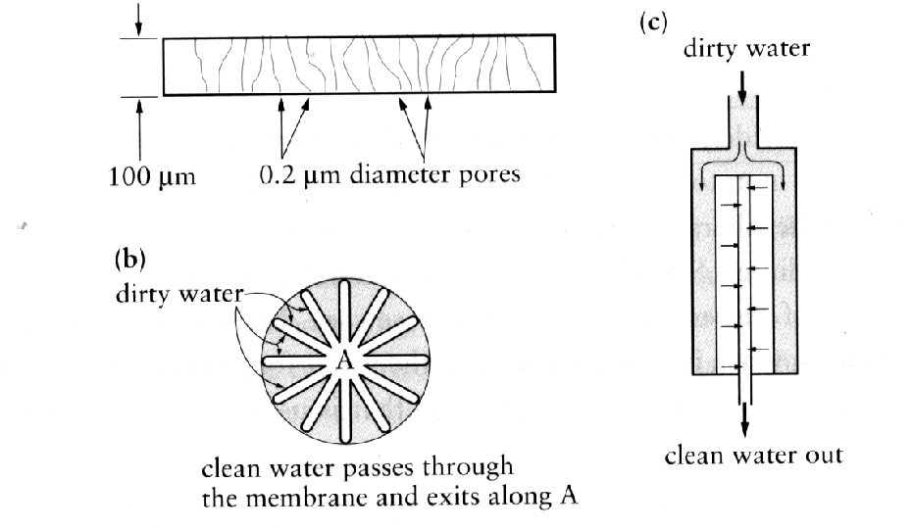

END OF PART 1 

